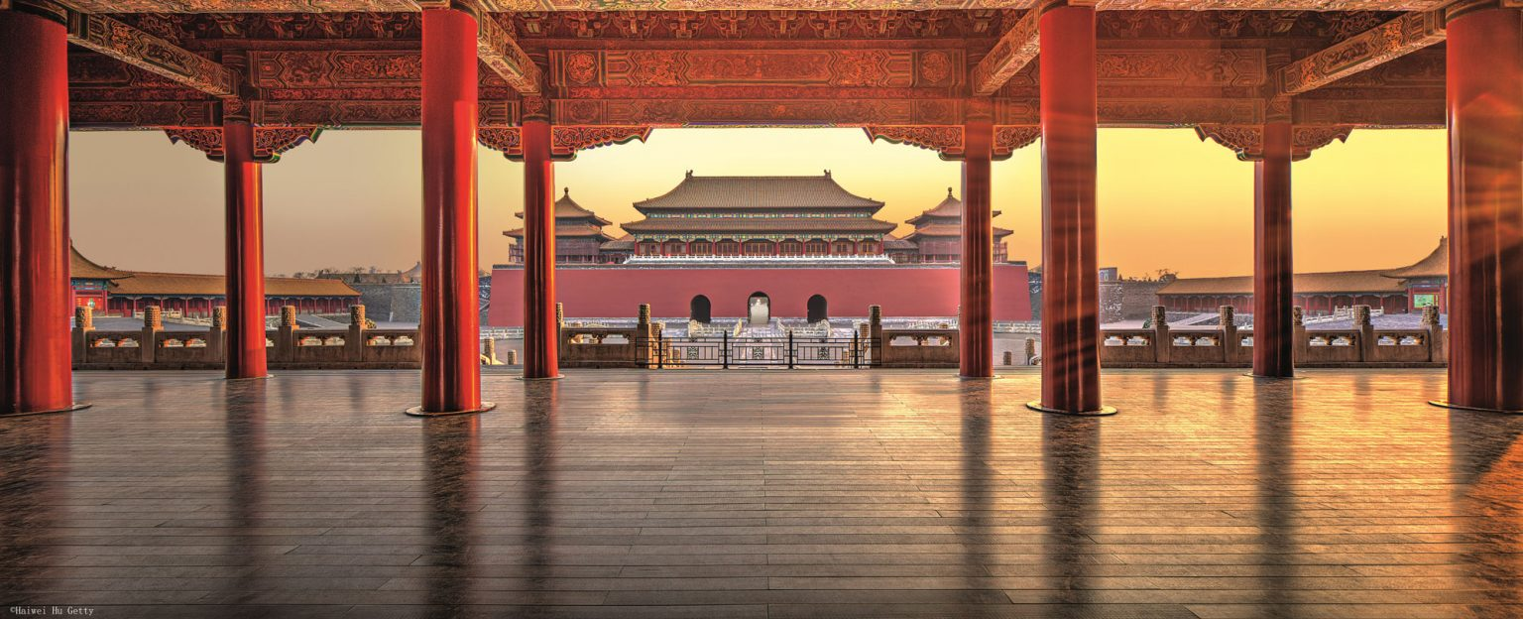

The **Forbidden City** ([Chinese](https://en.wikipedia.org/wiki/Chinese_language): 紫禁城; [pinyin](https://en.wikipedia.org/wiki/Pinyin): Zǐjìnchéng) is the [imperial](https://en.wikipedia.org/wiki/Chinese_Empire) [palace](https://en.wikipedia.org/wiki/Chinese_palace) complex in the center of the [Imperial City](https://en.wikipedia.org/wiki/Imperial_City,_Beijing) in [Beijing](https://en.wikipedia.org/wiki/Beijing), [China](https://en.wikipedia.org/wiki/China). It was the residence of 24 [Ming](https://en.wikipedia.org/wiki/Ming_dynasty) and [Qing](https://en.wikipedia.org/wiki/Qing_dynasty) dynasty [Emperors](https://en.wikipedia.org/wiki/List_of_Chinese_monarchs), and the center of political power in [China](https://en.wikipedia.org/wiki/China) for over 500 years from 1420 to 1924. The palace is now administered by the [Palace Museum](https://en.wikipedia.org/wiki/Palace_Museum). As a [UNESCO World Heritage Site](https://en.wikipedia.org/wiki/World_Heritage_Site), it is one of the most popular tourist attractions in the world. The Forbidden City is arguably the most famous [palace](https://en.wikipedia.org/wiki/Chinese_palace) in all of [Chinese history](https://en.wikipedia.org/wiki/History_of_China), and is the largest preserved [royal palace](https://en.wikipedia.org/wiki/Palace) complex still standing in the world.

The Forbidden City was constructed from 1406 to 1420, and was the imperial palace and winter residence of the [Emperor of China](https://en.wikipedia.org/wiki/Emperor_of_China) from the [Ming dynasty](https://en.wikipedia.org/wiki/Ming_dynasty) (since the [Yongle Emperor](https://en.wikipedia.org/wiki/Yongle_Emperor)) to the end of the [Qing dynasty](https://en.wikipedia.org/wiki/Qing_dynasty), between 1420 and 1924. The Forbidden City served as the home of Chinese emperors and their households and was the ceremonial and political center of the [Chinese government](https://en.wikipedia.org/wiki/Government_of_China) for over 500 years. Since 1925, the Forbidden City has been under the charge of the [Palace Museum](https://en.wikipedia.org/wiki/Palace_Museum), whose extensive collection of artwork and artifacts was built upon the imperial collections of the Ming and Qing dynasties. The Forbidden City was declared a [World Heritage Site](https://en.wikipedia.org/wiki/World_Heritage_Site) in 1987.[[2]](https://en.wikipedia.org/wiki/Forbidden_City#cite_note-UNESCO-2)

The complex claims to consist of 9,999 rooms in total, although experts have shown in recent years that the number only amounts to 8,886,[[3]](https://en.wikipedia.org/wiki/Forbidden_City#cite_note-Oakland-3) covering 72 ha (720,000 m2)/178-acre.[[4]](https://en.wikipedia.org/wiki/Forbidden_City#cite_note-Lu-4)[[5]](https://en.wikipedia.org/wiki/Forbidden_City#cite_note-UNESCO-ABE-5) The palace exemplifies the opulence of the residences of the Chinese emperor and the traditional [Chinese palatial architecture](https://en.wikipedia.org/wiki/Chinese_architecture),[[2]](https://en.wikipedia.org/wiki/Forbidden_City#cite_note-UNESCO-2) and has influenced cultural and architectural developments in [East Asia](https://en.wikipedia.org/wiki/East_Asia) and elsewhere. It is listed by [UNESCO](https://en.wikipedia.org/wiki/UNESCO) as the largest collection of preserved ancient wooden structures in the world. Since 2012, the Forbidden City has seen an average of 14 million visitors annually, and received more than 19 million visitors in 2019.[[6]](https://en.wikipedia.org/wiki/Forbidden_City#cite_note-6) In 2018, the Forbidden City's market value was estimated at US$70 billion, making it both the world's most valuable palace and the most valuable piece of real estate anywhere in the world.[[7]](https://en.wikipedia.org/wiki/Forbidden_City#cite_note-7)

It was listed as the first batch of national key cultural relics in 1961.[[8]](https://en.wikipedia.org/wiki/Forbidden_City#cite_note-8) The palace is extremely important to the Chinese public and nation, who often view it as a cultural and heavenly link to their ancestors.